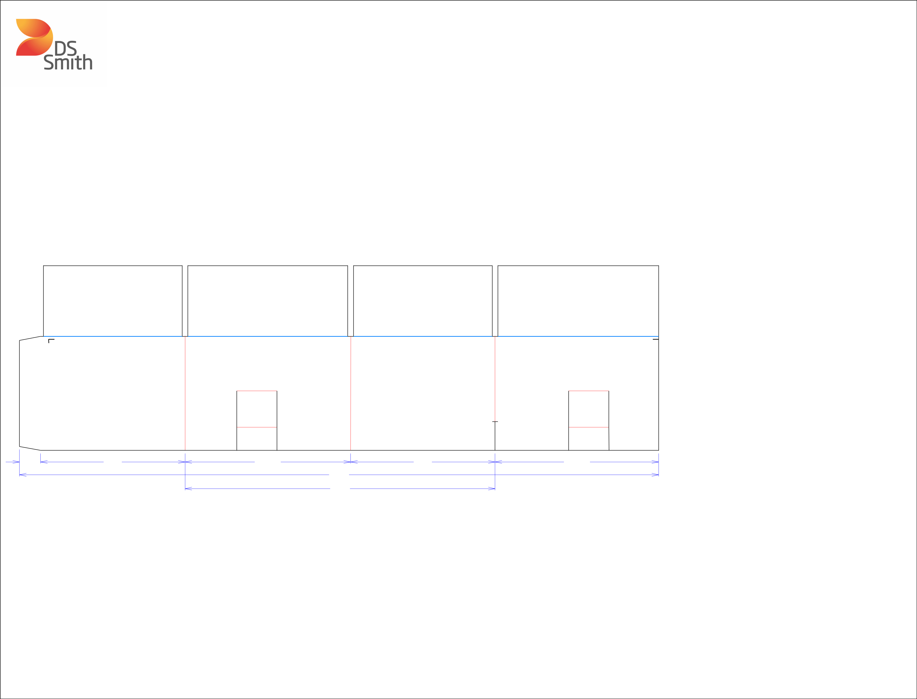

|  |
| --- |
| OUTSIDE GLUE |

|  |  |  |
| --- | --- | --- |
| 13*/*8 | 97*/*16 | 1013*/*16 |
|  |  | 413*/*4 |
|  |  | 201*/*4 |

|  |  |  |  |
| --- | --- | --- | --- |
| 7 | | 16 |  |
| 9 |  |  |
|  | */* | |  |

1011*/*16

Structural Design

(Inside View)

**Vertical corrugation**

Design#:

**200140-02_B**

Customer:

**DeMet's Candy**

Description:

**TTLS 8x6.4oz DCA SUB Holiday DRC - Cover**



|  |  |  |  |  |  |  |  |  |
| --- | --- | --- | --- | --- | --- | --- | --- | --- |
|  |  |  |  |  |  | **SINGLE-OUT DRAWING** | |  |
|  |  |  |  |  | Qty/Unit: | |  |  |
| 5 |  |  |  |  |  |  |
| 8 | | |  |  |  |  |  |  |
| */* | | |  |  |  |  |  |  |
| 4 | | |  |  |  |  |  |  |
|  |  |  |  |  | Style: | **PJDC** |  |  |
|  |  |  |  |  |  |  |
|  |  |  |  |  | Board: | **32BK** |  |  |
|  |  |  |  |  |  |  |
|  | 1 | |  |  | Combination: **35HP - 23M - 35HP** | | |  |
|  | 16 | | | |  |  |  |  |
|  | */* | | | |  |  |  |  |
|  | 12 | | | |  |  |  |  |
|  |  |  |  |  | I.D. : | **10+5/8 x 9+5/16 x 7+1/8** | |  |
|  |  |  |  |  |  |
| 16 | | |  |  |  |  |  |  |
| */* | | |  |  |  |  |  |  |
| 7 |  |  |  |  |  |  |  |  |
| 7 | | |  |  |  |  |  |  |
|  |  |  |  |  | Area of Blank - Waste : | | **3.41 sq. ft.** |  |
|  |  |  |  |  |  |
|  |  |  |  |  | Waste on Blank : | | **2.54%** |  |
|  |  |  |  |  | Finished Piece Weight: | | **0.35 lbs./159.43g** |  |



Over-all Blank: **12+1/16 x 41+3/4**

**Matrix ALL Scores**

**OUTSIDE GLUE**

**X= Crush Areas Required**

Notes:

**OUTSIDE GLUE**

Revision Info: **[B] 03/09/2020**

**Increase flaps - AK 3/9/20**

Designer: **Amy Kirchhoff**



Cut Crease Crease with Matrix Cut Crease Half Knife Cut Tear Tape Perforation



Designright and Copyright of DS Smith Corrugated Packaging Ltd. This technical Specification is subject to Manufacturing tolerances. Drawing dimensions shown are crease to crease. Date printed: 03/10/2020